**EXP:- DOORBELL USING BUZZER AND ARDUINO**

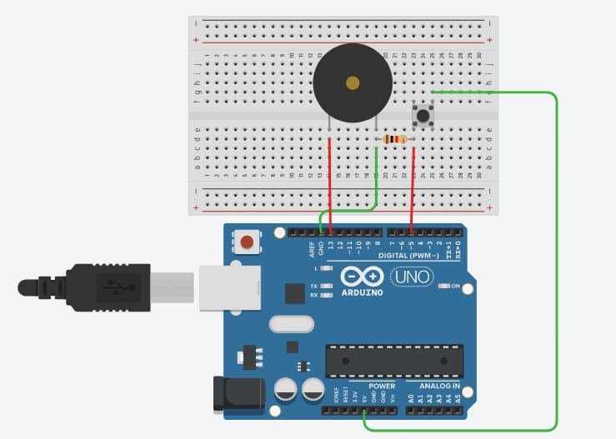

***Concept Used : -***

A circuit is made in which 2 digital pins are used where a pin (lets say 7) is

connected to a buzzer which is further connected to ground. Now another pin

(lets say 12) is connected to switch. One end of the switch is connected to 5V

supply and intersection of pin 12 and switch is connected to resistor which is

connected to ground from another end. Value of resistance is very high. The

resistors are used to resist the flow of current. Coding is done in such a way that

when switch is pressed buzzer starts making sound and again when switch is

pressed buzzer do not make any sound.

***Learning and Observations : -***

• Making circuits using Arduino.

• Connecting buzzer and switch with arduino.

• Ground has least resistance.

• Working of Arduino UNO.

• Coding to be done on Arduino.exe for stimulation of the experiment.

***Problems & Troubleshooting: –***

No problem occurred during the execution of the experiment.

***Precautions :–***

1. The circuit made can be wrong.

2. Any Element used may be defective.

3. The coding done can be incorrect due to which stimulation can be failed.

4. Port Selection for Arduino can be incorrect due to which it won’t upload on

Arduino Board and resulting in failure of experiment.

***Learning Outcomes: –***

1. Setting up circuit on a Arduino.

2. Connecting switch, buzzer and Arduino.

3. Using switch and buzzer.

4. Working and coding of Arduino.

***Result: –***

Working of buzzer and switch verified after uploading the program. Door bell is

ready to ring.